Matter Waves and Special Relativity

If you would be a real seeker after truth, you must at least once in your life doubt, as far as possible, all things.
⎯René DesCartes
Discours de la Méthode. 1637.

INTRODUCTION

And God said,”Let there be light”, and there was light.
⎯The Bible, Genesis 1:4

Early attempts at a wave theory of light presumed that light waves propagate through a universal medium in the same manner as sound waves through air. This medium was dubbed the luminiferous ‘aether’. For a comprehensive history, see Whittaker [1951], from which most of the following synopsis is derived. In 1690 Christian Huygens published an explanation of reflection and refraction based on the principle that each surface of a wave-front can be regarded as a source of secondary waves. Huygens also discovered that birefringent crystals can separate light rays into two distinct components (polarizations). Isaac Newton, among others, doubted the wave hypothesis in part because it could not explain this property of polarization. Nonetheless Newton did perceive a similarity between color and the vibrations which produce sound tones.

Christian Huygens
Need permission of SPL/Photo Researchers
Source: http://www.windows.ucar.edu/tour/link=/people/enlightenment/huygens.html
The source of this material is Windows to the Universe, at http://www.windows.ucar.edu/ at the University Corporation for Atmospheric Research (UCAR). ©1995-1999, 2000 The Regents of the University of Michigan; ©2000-03 University Corporation for Atmospheric Research.

No satisfactory explanation of polarization was found until Thomas Young suggested in 1817 that light waves consist of transverse vibrations such as occur in an elastic solid. Young was convinced of the wave nature of light because unlike particles of matter, light propagates with a characteristic velocity. Augustin Fresnel adopted Young’s idea of transverse vibrations and developed a highly successful theory which explained diffraction and interference in addition to reflection and refraction. He supposed the aether to resist distortion in the same manner as a elastic solid whose density is proportional to the square of the refractive index.

A conceptual problem with a solid aether is the question of how ordinary matter can coexist and move freely through it. George Gabriel Stokes proposed that the aether was analogous to a highly viscous fluid or wax: elastic for rapid vibrations but fluid-like with respect to slow-moving matter. A more direct difficulty with the solid aether model was that density variations (e.g. at the interface between vacuum and medium) led to coupling between transverse and longitudinal waves, a phenomenon not observed for light waves. James MacCullagh [1839] avoided this problem by proposing a ‘rotationally elastic’ aether whose potential energy Φ depends only on rotation (approximated by curl of displacement a):
$$Φ=\frac{1}{2}μ{\left(∇×a\right)}^{2}$$
The resulting wave equation is:
$$ρ\frac{∂^{2}a}{∂t^{2}}=−μ∇×\left(∇×a\right)$$
which is simply the equation of shear elastic waves which we derived in Chapter 1. Matter was now presumed to alter the elasticity of the aether rather than its density. This model successfully accounted for all of the known properties of light. Joseph Boussinesq [1867] proposed that the aether could be regarded as an ordinary ideal elastic solid whose physical properties (density and elasticity) are unchanged by interaction with matter. The optical properties of matter were thus entirely due to the manner in which matter interacts with the aether. With this approach any classical optical phenomenon could be consistently modeled simply by finding the appropriate interaction term.

In spite of these successes, scientists continued to pursue theories of a fluid aether through which matter could propagate. William Thomson (Lord Kelvin) [1887] attempted to model the aether as a ‘vortex sponge’: a fluid full of small-scale vortices with initially random orientation. He argued that this system could support transverse waves analogous to those in an elastic solid. James Clerk Maxwell modeled the aether as a network of rotating elastic cells interspersed with rolling spherical particles in order to derive the equations of electricity and magnetism in 1861-2 [Whittaker 1951 p. 250]. His resultant equations for light waves are equivalent to those of MacCullagh.

Since matter was presumed to move through the aether as particles moving through a fluid, many attempts were made to directly measure the relative motion between the earth and the aether. The most notable of these was an experiment first reported by Albert Michelson in 1881 and subsequently improved in 1887 with the aid of E. W. Morley [Michelson and Morley 1887]. Interference fringes were formed by combining two beams of light which propagated along perpendicular paths. If the earth moves with respect to the aether then light propagating back and forth along a path aligned with the earth’s motion should have a slightly slower average velocity than light propagating perpendicular to the earth’s motion. Therefore the fringes should shift if the apparatus is rotated so that a given beam is alternately parallel and perpendicular to the direction of the earth’s motion. However, no such effect was observed in this or other ‘aether-drift’ experiments.

Sir Oliver Lodge demonstrated in 1892 that the velocity of light is not noticeably affected by nearby moving matter, indicating that aether is not dragged along with matter. George FitzGerald proposed that the inability to measure motion relative to the aether could be explained if matter contracts along the direction of motion through the aether. Joseph Larmor [1900] noted that in addition to the shortening of length, moving clocks should also run slower by the factor ${\left(1−w^{2}/c^{2}\right)}^{1/2}$. Hendrik Lorentz in 1903 derived the appropriate coordinate transformations using the condition that the quantity $\left(x^{2}+y^{2}+z^{2}−c^{2}t^{2}\right)$ should be invariant. Henri Poincare [1904] gave the name ‘Principle of Relativity’ to the doctrine that absolute motion is undetectable. He also deduced from this principle that no velocity can exceed the speed of light. Albert Einstein [1905] reformulated relativity with the more positive assertion that the speed of light is a universal constant independent of observer motion .

One difficulty with the classical theory of light was a lack of success in describing radiation from a cavity at a fixed temperature (a ‘black body’). Max Planck [1900] derived the correct formula for blackbody radiation by supposing light to be emitted by vibrators whose energy $ε=\text{nh}ν$ is an integral multiple n of a constant h multiplied by the frequency ν. Einstein used the idea that radiation consists of discrete quanta in order to explain the photo-electric effect, in which the frequency of light must exceed a certain threshold in order to liberate electrons from a metal. Niels Bohr [1913] used quantization of angular momentum and energy to derive energy levels and spectral frequencies of the hydrogen atom. Recognizing that quantization is often associated with waves and vibrations, Louis Victor de Broglie [1924] proposed in his doctoral thesis that electrons have a wave-like character with energy $ε=ℏω$ and momentum $p=ℏk$. Bohr’s quantization of angular momentum is then equivalent to the requirement that stable electron orbits contain an integral number of electron wavelengths. Walter Elsasson suggested that this wave property of electrons might explain maxima and minima in the angular distribution of electrons scattered from a platinum plate in experiments reported by Clinton Davisson and Charles Kunsman. The wave nature of electrons was confirmed in 1927 when electron diffraction by crystals was clearly demonstrated in experiments by Davisson and Lester Germer [1927], and independently by George Thomson [1927].

The discovery of the wave-like propagation of matter actually solves the historic dilemma of how matter can move freely through a solid aether. In addition, the elastic medium itself need not change at all at the interface between vacuum and matter, thus explaining the lack of coupling to longitudinal waves. The wave nature of matter also leads directly to the Principle of Relativity without any modification of the classical Galilean view of Euclidean space and absolute time, as will be shown below.¹ However, mechanical modeling of fundamental physical processes was no longer in vogue at the time of this discovery. Matter waves were not regarded as ordinary classical waves.

Measurements with waves

“… a great step would be made when we should be able to say of electricity that which we say of light, in saying that it consists of undulations.”
⎯Sir George Gabriel Stokes, 1879

The first part of the following discussion closely follows Einstein’s explanation of special relativity [Einstein 1956] but with different rationale. Let us consider the transformations between coordinates of relatively moving observers who measure distances by timing how long it takes for waves to propagate back and forth between two points. The defining equation would be:
$d_{s}^{2}={\left(Δx\right)}^{2}+{\left(Δy\right)}^{2}+{\left(Δz\right)}^{2}=\sum_{i=1}^{3}{{\left({Δx}_{i}\right)}^{2}}=c^{2}t_{p}^{2}$ ()
where d_{s} is the spatial distance between two points at a fixed time, c is an arbitrary constant, and t_{p} is the time it would take to propagate a wave from one point to the other if they remained stationary. With this definition of distance, the constant c is simply a scaling factor which relates the units of distance to the units of time. This distance corresponds to the usual definition of distance if c is the speed of the wave used in the measurement.
Now suppose we consider propagation of a wave from point P₁ to point P₂. In a reference frame in which the points are stationary, Eq. 3 holds. An observer in a different inertial reference frame using the same definition of distance would have:
$\sum_{i=1}^{3}{{\left(Δx_{i}^{'}\right)}^{2}}=c^{2}t_{p}^{}$ ()
The quantity ${\left(Δx\right)}^{2}+{\left(Δy\right)}^{2}+{\left(Δz\right)}^{2}−c^{2}t_{p}^{2}$ is therefore zero for both observers. Allowing for an arbitrary offset, the invariance of this quantity for different observers is precisely the condition which Lorentz used to derive the relativistic transformations. The quantity ${\left(c^{2}t^{2}−x^{2}−y^{2}−z^{2}\right)}^{1/2}$ is called the ‘separation’.
For example, suppose a submarine navigator is using sonar both to measure time and to detect fish in the water. The sailors use special sonar clocks which measure time by cycling sound wave pulses back and forth across a fixed distance in the water perpendicular to the direction of motion. Each cycle of wave transmission, reflection, and detection at the original site of transmission constitutes a tick of the clock. In this analysis we will neglect any effects of displacement of water by moving submarines.
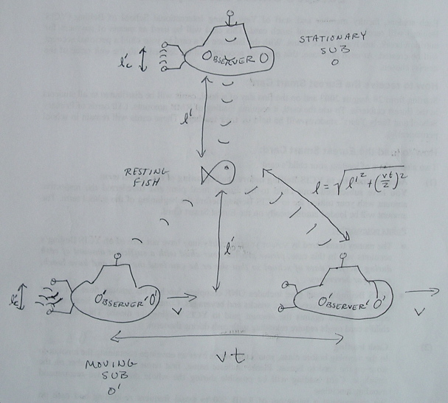
Figure 1. Time Dilation: The clock on O′ ticks slower than the clock on O by the factor $\sqrt{1−v^{2}/c_{s}^{2}}$because waves travel farther between transmission and detection. Both O and O′ measure the same number of clock cycles for a wave to propagate from their own sub to the fish and back. Hence they agree on distances perpendicular to the direction of relative motion.

Time dilation
If both the sub and the fish are at rest in the water, a sound wave reflected from the fish at distance  would return after time t=2/c_{s}, where c_{s} is the sound speed. The distance to the fish is therefore taken to be = c_{s}t/2. Suppose now that the sub and fish are moving together in the water with common speed v perpendicular to the original direction of wave propagation (Figure). The path of the sonar clock waves forms two sides of a triangle for each cycle. A similar triangle is formed by the wave propagation to the fish and back. Therefore the number of clock ticks which occur during wave propagation to the fish and back is independent of speed. If the navigator doesn’t realize that she is moving, she would assume the same relation between distance and time: ′== c_{s}t′/2. The navigator of a second submarine sitting still in the water would observe the wave propagate over a distance:
$d≡c_{s}t=2\sqrt{ℓ^{2}+{\left(\frac{\text{vt}}{2}\right)}^{2}}$ ()
Substituting = c_{s} t′/2 and solving for t´ yields:
$t^{'}=t\sqrt{1−v^{2}/c_{s}^{2}}$ ()
This equation merely expresses the fact that the clock on the moving submarine ticks more slowly that the stationary clock because the waves have farther to travel between ticks. Hence the time (t) measured by the stationary observer is longer than the time (t′) measured by the moving observer. This phenomenon is referred to as ‘time dilation’.
It is obvious that if the unprimed observer is truly stationary with respect to the water, then the moving clock does in fact tick more slowly. This is not merely an illusion. What is interesting is that the wave measurements performed by these submarines are insufficient to determine which sub is actually moving with respect to the water. Therefore the moving sub would interpret the stationary clock as running slowly, and in this case the effect is an illusion. This point will be discussed below in connection with Doppler shifts.
Since the stationary navigator sees the fish (and first sub) move a distance x=vt while the wave is propagating, the above equation can be rewritten as:
$t^{'}=\frac{t\left(1−v^{2}/c_{s}^{2}\right)}{\sqrt{1−v^{2}/c_{s}^{2}}}=\frac{t−\text{vx}/c_{s}^{2}}{\sqrt{1−v^{2}/c_{s}^{2}}}$ ()
which is the Lorentz transformation of time between two observers, with the primed observer moving in the x-direction with velocity +v with respect to the unprimed observer.

Length contraction
Since both observers measure the same distance ′=, the transformation of coordinates perpendicular to the motion must be simply:
$$\begin{aligned}y^{'}=y \\ z^{'}=z\end{aligned}$$
Now suppose that the first sub and fish are moving relative to the second sub parallel to the direction of wave propagation. (Figure)
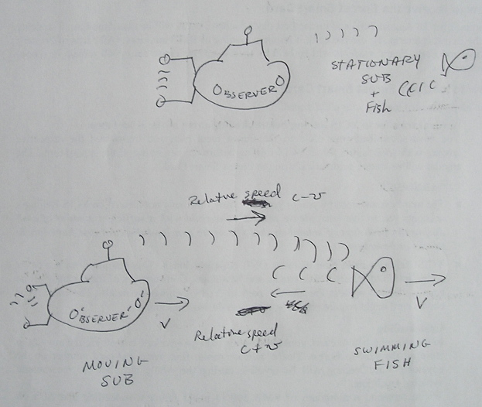
Figure 2. Length Contraction: The true wave propagation time for the co-moving sub and fish is longer than for the stationary sub and fish by the factor 1/(1-v²/c_{s}²). Since the moving clock runs slow, the perceived propagation time is longer only by the factor $1/\sqrt{1−v^{2}/c_{s}^{2}}$. Hence the stationary sub observes a shorter length than the moving sub.

As seen by the stationary sub, the frequency of the sonar clock on the first sub is slow according to Eq. 6 since the measured time t′ is proportional to the moving clock frequency ω′ times the absolute time t:
$ω^{'}=ω\sqrt{1−v^{2}/c_{s}^{2}}$ ()
The absolute distance between the fish and sub remains constant at . However the relative speed between the outgoing wave and the target fish is (c-w) whereas the relative speed between the sub and the incoming wave is (c+w). Therefore the propagation time is:
$t=\frac{ℓ}{\left(c+v\right)}+\frac{ℓ}{\left(c−v\right)}=\frac{2ℓ}{c\left(1−v^{2}/c^{2}\right)}$ ()
Of course the moving sub still uses the relation ′= c_{s}t′/2. Substituting the temporal relation $t^{'}/t=\sqrt{1−v^{2}/c^{2}}$ yields the relation between lengths:
$ℓ^{'}=\frac{\text{ct}\sqrt{1−v^{2}/c^{2}}}{2}=\frac{ℓ}{\sqrt{1−v^{2}/c^{2}}}$ ()
The stationary observer measures a shorter length than the moving observer. This phenomenon is known as length contraction. In this case the moving observer measurement is artificially long due to the fact that the actual sound velocity relative to the observer is not the same for the outgoing and incoming directions. Since the wave propagates for a longer time in the direction of slower relative motion, the effect is an apparent increase in length relative to a stationary observer. Again, however, it is important to realize that the wave measurements alone do not determine which observer is moving.
As noted previously, the origin of the moving frame corresponds to x=vt in the stationary frame. Therefore the coordinate transformation is obtained by ′→x′ and  →x −vt:
$x^{'}=\frac{x−\text{vt}}{\sqrt{1−v^{2}/c_{s}^{2}}}$ ()
which is the Lorentz transformation of position along the direction of motion.
It is customary to use the definitions:
$\begin{aligned}β=v/c_{s} \\ γ={\left(1−v^{2}/c_{s}^{2}\right)}^{−1/2}\end{aligned}$ ()
A useful identity is:
$1+β^{2}γ^{2}=γ^{2}$ ()
Using the above expessions, the Lorentz transformations become:
$\begin{aligned}c_{s}t^{'}={γc}_{s}t−\text{βγ}x \\ x^{'}=γx−\text{βγ}c_{s}t \\ y^{'}=y \\ z^{'}=z\end{aligned}$ ()
where subscripts are used to emphasize that we are discussing sound waves.
The inverse transformations merely change the sign of v (or β):
$\begin{aligned}{c_{s}t={γc}_{s}t^{'}+\text{βγ \{}x}^{'}\end{aligned}x=γx^{'}+\text{βγ}c_{s}t^{'}y=y^{'}z=z^{'}$ ()
Thus we see how Lorentz transformations can be obtained by using sonar or any other type of wave to measure time and distance. Lorentz invariance is not a property of time and space per se. Rather it results from the methods used to measure time and distance. If the above-mentioned sailors were to rendezvous to share their data and some vodka, they might conclude after a few drinks that absolute time and space in moving underwater reference frames are related by Lorentz transformations using the speed of sound in water. After sobering up, however, they would realize that sonar is not the only way to measure time and distance and that their measurements are not evidence of any non-classical properties of underwater space-time.

Length and time standards
The sonar clock might seem like an odd sort of clock, but consider the standard definition of a second, which is 9,192,631,770 periods of the radiation corresponding to the transition between the two hyperfine levels of the ground state of the cesium 133 atom [Taylor 1995]. If we regard the cesium atom as a kind of optical cavity which resonates at the prescribed frequency, then this is quite similar to our sonar clock.
Consider also that the standard definition of the meter is the length of the path traveled by light in vacuum during a time interval of 1/c =1/299,792,458 of a second [Taylor 1995]. So we do in fact equate length with wave propagation time just as our hypothetical sailors do, and the quantity c is nothing more than a unit conversion factor.

Doppler shift
Thus far we have shown that when waves are used to measure distance and time, the space-time coordinates transform between relatively moving observers according to the Lorentz transformations. Transformations of other dynamical variables is straightforward.
The phase of a plane wave is given by:
$φ=k⋅x−ωt$ ()
This quantity should be independent of observer motion. Therefore:
$$k^{'}⋅x^{'}−ω^{'}t^{'}=k⋅x−ωt$$
For motion along the x-axis we can plug in the inverse transformations for x and t to obtain:
$\begin{aligned}k_{x}^{'}x^{'}−ω^{'}t^{'}=k_{x}\left(γx^{'}+\text{βγ}c_{s}t^{'}\right)−ω\left(γt^{'}+\text{βγ}x^{'}/c_{s}\right) \\ k_{y}^{'}y^{'}=k_{y}y \\ k_{z}^{'}z^{'}=k_{z}z\end{aligned}$ ()
The coefficients of t′ must be equal on both sides of the equation, and likewise for the coefficients of x′. Therefore:
$\begin{aligned}ω^{'}=\text{γω}−\text{βγ}c_{s}k_{x} \\ k_{x}^{'}={γk}_{x}−\text{βγ}ω/c_{s} \\ k_{y}^{'}=k_{y} \\ k_{z}^{'}=k_{z}\end{aligned}$ ()
Letting β=v/c, the transformation for arbitrary direction of relative velocity is:
$\begin{aligned}ω^{'}=γ\left(ω−β⋅ck\right) \\ ck_{||}^{'}=γ\left({\text{ck}}_{||}−\text{βω}\right) \\ k_{}^{'}=k_{}\end{aligned}$ ()
Hence the spatio-temporal frequency components (ω,ck) transform in the same manner as the coordinates (ct,x). Quantities which transform according to these Lorentz transformations are called ‘four-vectors’. Each four-vector has three spatial components and a temporal component. Other examples of four-vectors include:
$$\begin{matrix}\left(γc,γv\right) & \text{Four}−\text{velocity} \\ \left(E/c=γ\text{mc},p=γmv\right) & \text{Energy, momentum} \\ \left(ρc,J\right) & \text{Electromagnetic charge, current}\end{matrix}$$
Note that for light waves |ck|=|ck′|=ω. Hence the frequency and wave vector transformations for motion parallel to k can be written as:
$\begin{aligned}ω^{'}=\text{γω}\left(1−β\right)=ω\sqrt{\frac{1−β}{1+β}} \\ k_{||}^{'}={γk}_{||}\left(1−β\right) \\ k_{}^{'}=k_{}\end{aligned}$ ()
The first of these equations is the relativistic Doppler shift formula for light waves.
The relativistic Doppler shift has a simple interpretation. First, consider the classical Doppler shifts as shown in the Figure below.
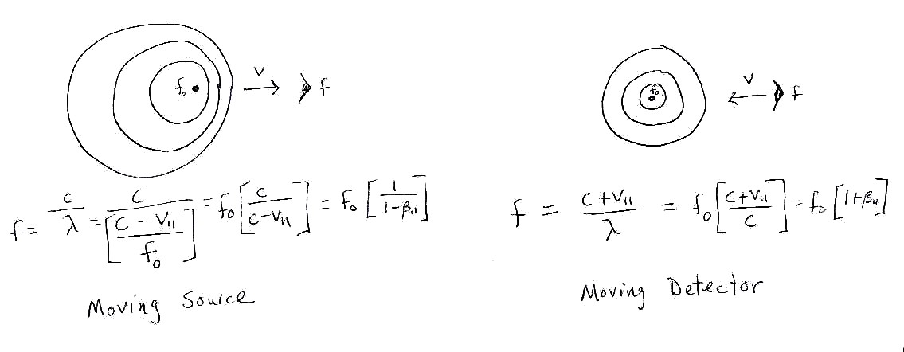
Figure: Classical Doppler shifts for moving (approaching) source and detector differ by a factor of $\left[1+β\right]\left[1−β\right]=1/γ^{2}$. This factor is not affected by reversal of the velocity direction.

Consider a stationary observer O in a lighthouse which pulsates with angular frequency ω. An observer O′ moves away from the lighthouse starting at t=0 in a speedboat. As a moving detector, O′ receives a classically Doppler-shifted frequency of$ω\left(1−β\right)$. However, O′’s clock is running slow by the factor 1/γ because the boat is moving. Hence O′ perceives the incident wave frequency to be higher by the factor γ so that ω′=γ$ω\left(1−β\right)$. The stationary observer O would agree with this correct description of events. Note that observer O can measure the speed of observer O′ by measuring the time of flight of radar pulses which reflect off of O′ and back to O. Successive pulses separated by transmission time interval τ_{T} will be received with delay time interval τ_{R}=τ_{T}(1+v/c), yielding v=c(τ_{R} −τ_{T})/ τ_{T}.
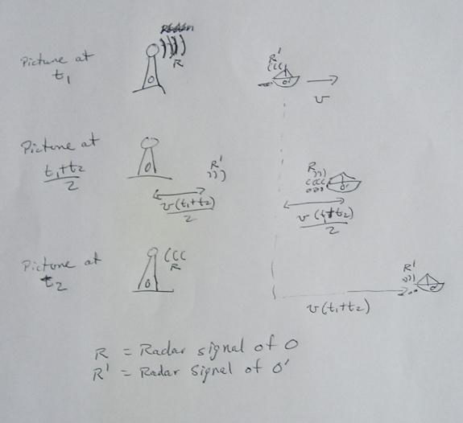
Figure 3. Velocity Measurement: Radar signals sent simultaneously by O and O′ will also be received simultaneously after reflection. Although O′’s clock ticks slowly, the proportionality between radar pulse propagation time and total time elapsed is the same as for O. Therefore both O and O′ measure the same relative velocity.

Conversely, the observer O′ incorrectly believes that he is stationary and that O is moving. O′ measures the speed of recession of the lighthouse via radar. The true propagation time of the each pulse is the same as measured by O (see Figure above). The fact that O′’s clock is running slowly reduces all of his measured times by the factor 1/γ, but this does not affect the proportionality between the transmission time interval and the reception time interval. Therefore O′ sees O recede with speed v.
Observer O′ observes the lighthouse light fluctuate with frequency ω′=γ$ω\left(1−β\right)$. This formula accounts for slowing of the moving clock and Doppler shift at the moving (receding) receiver. O′ presumes the detected frequency to be classically Doppler shifted at the source by a factor of $1/\left(1+β\right)$. Correcting for this Doppler shift yields $ω^{'}\left(1+β\right)$ for the co-moving source frequency. Since O′ thinks that O’s clock is slow, the correction factor γ is again introduced to obtain the frequency perceived at the source. This leads to:
$ω=γω^{'}\left(1+β\right)=ω^{'}\left(\sqrt{\frac{1+β}{1−β}}\right)$ ()
which is of course the inverse frequency transformation. Note that O′ incorrectly attributes the Doppler shift to a moving source rather than a moving detector, resulting in an erroneous factor of (1+β)(1−β)=1/γ². However, this mistake is exactly compensated by the fact that O′ incorrectly believes that O’s clock is running slower by the factor 1/γ when in fact it is running faster by the factor γ. O′ mistakenly multiplies by γ when he should have divided by gamma to correct for the different clock rates (an erroneous factor of γ²). The erroneous factors of γ² and 1/γ² cancel and O′ correctly deduces the frequency ω for the stationary source at O. This cancellation of errors renders impossible the determination of motion relative to the medium which carries the wave. It is the crux of special relativity.

Matter waves and light

It is better to light one small candle than to curse the darkness.
⎯Confucius

One limitation of the above discussion is that sound waves in water are too simple to serve as a model of matter. The sonar clock had to be oriented perpendicular to the direction of motion so that its apparent length was independent of velocity. Another problem is that sound waves are scalar waves, described by a single number (e.g. pressure) at each point. A more interesting medium to consider is an elastic solid, which can support shear waves whose amplitude (displacement or rotation) can have multiple components. Waves which include significant rotations are especially of interest because rotations of the medium can alter the direction of propagation of the waves. This variability of propagation direction is crucial to understanding how special relativity applies to matter waves.
The above results show that the equations of special relativity are applicable to a wide variety of wave phenomena. The Lorentz transformations relate wave measurements made in different frames of reference. It is well-known (and easily verified) that any wave equation of the form:
$\left[\frac{∂^{2}}{∂t^{2}}−c^{2}∇^{2}\right]f=0$ ()
is invariant under Lorentz transformations with wave speed c. In other words Lorentz invariance is a general property of waves and not specific to electromagnetic waves.
Now we are in a position to appreciate what is special about light. Ordinarily we do not measure distances and times by propagating waves back and forth. Instead we use material clocks and rulers. The amazing thing about material clocks and rulers is that the resulting distance and time measurements transform with exactly the same Lorentz transformations as would be obtained if the measurements had been made by propagating light waves. In other words, matter behaves as if it consists of waves which propagate at the speed of light. Since matter can appear to be stationary, we must suppose that the waves somehow propagate in cyclic paths in the ‘rest’ frame. Such waves are referred to as soliton waves.
Historically, the equations of relativity were derived from the observation that absolute motion is undeterminable. Einstein reformulated relativity on the basis that the speed of light is independent of observer motion. Yet now we have a simpler alternative postulate for special relativity: matter consists of waves which propagate at the speed of light. This physical picture suggests that matter and anti-matter can annihilate into photons and vice versa because photons and matter are simply different packets of the same type of wave. We will see that our new hypothesis is also consistent with the Dirac equation for the electron, in which the velocity operator has eigenvalues of magnitude c. Mass is associated with rotation of the propagation direction, which explains why the apparent speed is always less than the speed of light.
With respect to aether-drift experiments such as performed by Michelson and Morley, it is clear that if matter waves have the same speed as light waves then any effect of earth’s propagation through the vacuum would equally affect the light waves and the apparatus used to measure them. It has long been recognized that Lorentz invariance of matter is required to explain the null result of such experiments.² What has not been generally recognized is that the wave nature of matter provides the basis for relativity and is entirely consistent with classical notions of absolute space and time.

Soliton waves
Let the characteristic wave speed of transverse waves in an elastic medium be c_{Τ} to distinguish it from light and sound waves. The equation of evolution of any component of the wave amplitude a(x,t) is:
$\frac{∂^{2}a}{∂t^{2}}=c_{T}^{2}∇^{2} a$ ()
Suppose that a wave packet can be formed which propagates in a circular motion so that its energy remains localized. Such a wave packet is called a solitary wave or soliton. A translational component can be added to the motion to yield spiral or cycloidal wave paths. Although the local wave speed is the same as for waves propagating in straight lines (c_{Τ}), the velocity of the packet as a whole will always be less than c_{Τ} because of the circulating component of the motion. Assume for the moment that the translational motion is perpendicular to the plane of circulation so that the wave travels in a spiral. Separating the circulating (⊥) and translational (||) parts of the wave equation yields:
$\frac{∂^{2}a}{∂t^{2}}=c_{T}^{2}\left(∇_{}^{2}+∇_{||}^{2}\right) a$ ()
It is common to use Fourier decomposition so that the wave equation can be written as:
$ω^{2}A=c_{T}^{2}\left(k_{}^{2}+k_{||}^{2}\right)A$ ()
where A(k,ω) is the Fourier transform of the wave amplitude a(x,t). The wave packet must contain a range of k values in order to be localized. For the moment, however, it is convenient to consider a fixed value of k|| and fixed magnitude of k⊥. The translational component of wave velocity u in direction x|| is clearly given by:
$u=c_{T}\frac{k_{||}}{\left|k\right|}=c_{T}\frac{k_{||}}{{\left(k_{}^{2}+k_{||}^{2}\right)}^{1/2}}=c_{T}^{2}\frac{k_{||}}{ω}$ ()
Solving for k|| yields:
$\begin{aligned}k_{||}^{2}={\left(1−\frac{u^{2}}{c_{T}^{2}}\right)}^{−1}\frac{u^{2}}{c_{T}^{2}}k_{}^{2}≡γ_{T}^{2}\frac{u^{2}}{c_{T}^{2}}k_{}^{2} \\ k^{2}=ω^{2}/c_{T}^{2}=k_{||}^{2}\frac{c_{T}^{2}}{u^{2}}\end{aligned}$ ()
where we have used the familiar definition of γ_{Τ} to obtain the expression on the right.
Substitution into the wave equation yields:
$ω^{2}A=c_{T}^{2}k_{}^{2}\left[1+γ_{T}^{2}\frac{v^{2}}{c_{T}^{2}}\right]A=γ_{T}^{2}c_{T}^{2}k_{}^{2}A$ ()

Transformation of velocity
These identities are useful for working out the transformation properties of the velocity. For relative motion parallel to the velocity only the component k|| is affected :
$u^{'}=c_{T}^{2}\frac{k_{||}^{'}}{ω^{'}}=c_{T}^{2}\frac{γ_{T}k_{||}−\text{βγ}ω/c_{T}}{γ_{T}ω−\text{βγ}c_{T}k_{||}}=c_{T}\frac{1−βc_{T}/u}{c_{T}/u−β}=\frac{u−{βc}_{T}}{1−βu/c_{T}}=\frac{u−v}{1−\text{uv}/c_{T}^{2}}$ ()
This is the transformation law for velocity parallel to the direction of relative motion. For relative motion perpendicular to the velocity the only change is to ω:
$u^{'}=c_{T}^{2}\frac{k_{||}^{'}}{ω^{'}}=c_{T}^{2}\frac{k_{||}}{γ_{T}ω}=\frac{u}{γ_{T}}$ ()
For an arbitrary direction of relative motion v, we use $u_{||}=u⋅v/v$ to obtain the transformation laws for components of velocity parallel ($u_{||v}$) and perpendicular ($u_{v}$) to the direction of relative motion:
$$\begin{aligned}u_{||v}^{'}=c_{T}^{2}\frac{γ_{T}k_{||}−{\text{βγ}}_{T}ω/c_{T}}{γ_{T}ω−β⋅{kγ}_{T}c_{T}}=c_{T}^{2}\frac{u_{||}−{βc}_{T}}{c_{T}^{2}−c_{T}β⋅u}=\frac{u_{||}−v}{1−vu/c_{T}^{2}} \\ u_{v}^{'}=c_{T}^{2}\frac{k_{}}{γ_{T}ω−β⋅{kγ}_{T}c_{T}}=c_{T}^{2}\frac{k_{}}{γ_{T}\left[ω−β⋅{uωc}_{T}\right]}=\frac{u_{v}}{γ_{T}\left[\underset{}{1−u⋅v/c_{T}^{2}}\right]}\end{aligned}$$
$\begin{aligned}u_{||v}^{'}=\frac{u_{||v}−v}{1−u⋅v/c_{T}^{2}} \\ u_{v}^{'}=\frac{u_{v}}{γ_{T}\left(1−u⋅v/c_{T}^{2}\right)}\end{aligned}$ ()

Energy and momentum
For wave paths consisting only of circular and translational components, the variables ω, k||, and $k_{}^{2}$are constants and therefore the wave amplitude A(k,ω) can be removed from Eq. .
Identifying $c_{T}k_{}$ as the frequency ω₀ of a soliton with no translation (i.e. at rest), we see that
$ω^{2}=γ_{T}^{2}ω_{0}^{2}=ω_{0}^{2}+c_{T}^{2}k_{||}^{2}$ ()
A special property of electron waves, which will be discussed in Chapter 3, is that the energy is proportional to frequency ($E=ℏω$) and momentum is proportional to the average wave vector ($p=ℏ\left\langle k\right\rangle =ℏk_{||}$). Classically, the quantity  must represent the integrated wave amplitude. We assume that all matter waves have similar proportionalities, though perhaps with different integrated wave amplitudes. Using these substitutions yields:
$E^{2}=γ_{T}^{2}E_{0}^{2}=E_{0}^{2}+c_{T}^{2}p^{2}$ ()
The rest energy is proportional to the circulating component of momentum:
$E_{0}^{2}≡m_{0}^{2}c^{4}=c^{2}p_{}^{2}=c^{2}ℏ^{2}k_{}^{2}$ ()
The linear momentum density of the wave packet is derived from Eqs. 17 and 20 to be:
$p_{||}^{2}=ℏ^{2}k_{||}^{2}=γ^{2}\frac{ℏ^{2}k_{}^{2}}{c^{2}}v_{||}^{2}=γ^{2}m_{0}^{2}v_{||}^{2}$ ()
The total energy density can thus be written as:
$E^{2}=m_{0}^{2}c^{4}+p_{||}^{2}c^{2}=γ^{2}m_{0}^{2}c^{4}$ ()
This relativistic relation between mass and energy follows directly from the assumption that matter consists of soliton waves. We obtained it simply by applying the Pythagorean theorem to the wave vector components.
If the stationary frequency of an elementary particle is really associated with circular motion then we can compute the radius of the motion. For electrons we have:
$R=\text{511} \text{ keV}=ℏω=ℏc/R$ ()
Solving for the radius R yields:
$R=3\text{.}\text{86}×{\text{10}}^{−\text{11}} \text{cm}$ ()
Note that this quantity is different from the Bohr radius ($R_{e}=ℏ^{2}/{\text{me}}^{2}$) which estimates the spatial extent of electric charge.
The definitions of E and p_{i} lead directly to the equation of motion k_{i}E=ωp_{i} in the Fourier domain. In the spatial domain this is the classical relationship between kinetic energy and momentum:
$\frac{∂E}{∂x_{i}}=\frac{∂p_{i}}{∂t}$ ()
One limitation of the above analysis is that we assumed the bulk soliton motion to be perpendicular to the circulating motion. We should also consider bulk motion in the same plane as the circulation, which results in cycloidal motion. Let $k_{\text{circ}}={\hat{x}}_{}k_{}\text{cos}θ+{\hat{x}}_{||}k_{}\text{sin}θ$, where ${\hat{x}}_{}$is any direction perpendicular to the bulk propagation direction ${\hat{x}}_{||}$. In this case we cannot separate k⊥ and k||, so we must consider the integral of Eq. :
$\int{d^{3}k ω^{2}A}\left(k,ω\right)=\int{d^{3}k \left[c_{τ}^{2}k_{}^{2}{\text{cos}}^{2}θ+c_{τ}^{2}{\left|k_{}\text{sin}θ+k_{||}\right|}^{2}\right]A}\left(k,ω\right)$ ()
Assuming that A(k,ω) depends only on the magnitudes of k⊥ and k||, the cross term $c_{τ}^{2}k_{}k_{||}\text{sin}θ$ integrates to zero. Therefore the resulting energy-momentum relations will be equivalent to Eqs. -. In fact, the integral of k_{circ} must be zero if the wave with k||=0 is indeed stationary. Therefore it is clear that the energy-momentum relation of special relativity holds whether the wave circulation is parallel or perpendicular to the bulk motion.
We must also consider whether the relations derived above hold when a wider range of k-values is present. Let the integral of an arbitrary operator q be denoted by ⟨ q ⟩. Eq. was derived for a fixed k|| and fixed magnitude of k_{circ}. However, it is clear that if this equation holds for each set of (k||, k_{circ}) individually then it must also hold when integrated over all values of (k||, k_{circ}). Therefore:
$\left\langle ω^{2}\right\rangle =c_{τ}^{2}\left(\left\langle k_{\text{circ}}^{2}\right\rangle +\left\langle k_{||}^{2}\right\rangle \right)$ ()
If the soliton moves without changing shape (as seen by an observer moving along with the wave) then the velocity v|| (and consequently γ) is constant throughout the wave packet. We can therefore write:
$\left\langle ω^{2}\right\rangle =γ^{2}c_{τ}^{2}\left\langle k_{\text{circ}}^{2}\right\rangle$ ()
and all of the relativistic relations hold for the wave packet as a whole and not just individual k-values.

The twin paradox
One supposedly non-intuitive consequence of relativity is that two twins can change their relative age through motion. If one twin (Theo=O) remains stationary while the other twin (Primo=O′) takes a high-speed journey through space, then the twin who traveled will return younger that the twin who stayed home. A more common manifestation of this phenomenon is that high-energy cosmic ray particles which zoom to earth at relativistic speeds have longer lifetimes than otherwise identical slow-moving particles. Although the effect of motion on time may seem almost magical, the explanation is really quite simple.
Consider a clock which counts the number of circular orbits executed by an electron wave. Any clock made of matter waves will tick at a proportionate rate. While the stationary electron executes a circular path, a moving electron executes a spiral (or cycloidal) path with the same absolute speed c. Since the moving electron travels farther than the stationary electron during each rotation cycle, a moving electron clock (t′=ω′τ) will tick more slowly than a stationary one (t=ωτ). For a translational velocity of v||, the speed of circulation is:
$v_{}^{'}={\left(c^{2}−v_{||}^{2}\right)}^{1/2}=c/γ$ ()
and therefore the moving clock ticks more slowly (t′<t) by the factor:
$\frac{t^{'}}{t}=\frac{v_{}^{'}}{v_{}}=\frac{v_{}^{'}}{c}=1/γ$ ()
This is equivalent mathematically and similar physically to the derivation above of time dilation for sound waves in water. Hence the moving Primo will age less than the stationary Theo.

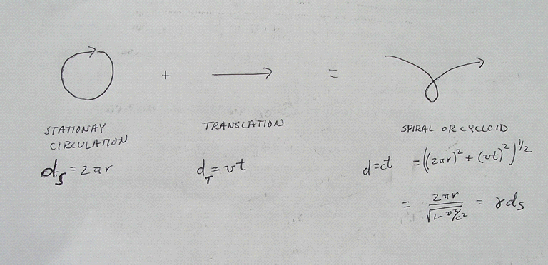
Figure 4. Twin Paradox: Moving matter waves propagate farther than stationary matter waves during each cycle. Therefore moving clocks tick more slowly than stationary clocks. d_{S} = distance traveled in one cycle of stationary wave, d_{T} = translational distance. Hence a traveling twin ages more slowly than a stationary one.

We have stated before that wave measurements cannot determine absolute motion relative to the medium. Therefore Primo should be younger than Theo even if they are initially moving with respect to the medium. Suppose that the two twins Primo and Theo are initially moving together with velocity v₁ in the x direction. A stationary observer sees Primo slow to a stop at t=0, wait for a time t=T₁, then accelerate to speed v₂ to catch up with Theo at time t= T₁+ T₂=T. In this case Primo is actually aging more rapidly than Theo at first, but then ages very slowly while trying to come back. Note that:
$$\begin{aligned}T_{1}=T\left(1−v_{1}/v_{2}\right) \\ T_{2}=T\left(v_{1}/v_{2}\right)\end{aligned}$$
At the time the twins meet up again, Theo has aged by T/γ₁ since his clock is running slower than a stationary clock (using $γ_{i}={\left(1−v_{i}^{2}/c^{2}\right)}^{−1/2}$). But Primo has aged by $T_{1}+T_{2}/γ_{2}=$$T\left(1−v_{1}/v_{2}+v_{1}/γ_{2}v_{2}\right)$. The difference in their ages is therefore:
$$T_{\text{Theo}}−T_{\text{Pr}\text{imo}}=T\left(\frac{1}{γ_{1}}−1+\frac{v_{1}}{v_{2}}\left(1−\frac{1}{γ_{2}}\right)\right)$$
To second order in v/c terms, this difference is:
$$T_{\text{Theo}}−T_{\text{Pr}\text{imo}}≈T\left(1−\frac{1}{2}\frac{v_{1}^{2}}{c^{2}}−1+\frac{v_{1}}{v_{2}}\left(1−\left(1−\frac{1}{2}\frac{v_{2}^{2}}{c^{2}}\right)\right)\right)=T\left(−\frac{1}{2}\frac{v_{1}^{2}}{c^{2}}+\frac{1}{2}\frac{v_{1}v_{2}}{c^{2}}\right)≥0$$
where the inequality arises from the fact that v₂≥ v₁. More generally, we can try to minimize the age difference with respect to v₂ (for a given T and v₁). The minimization condition is:

$$0=\frac{d}{{\text{dv}}_{2}}\left(\frac{1}{γ_{1}}−1+\frac{v_{1}}{v_{2}}\left(1−\frac{1}{γ_{2}}\right)\right)$$
which yields after a little algebra:
$$\frac{v_{1}}{v_{2}}\left(1−\frac{1}{γ_{2}}\right)=\frac{v_{1}v_{2}}{c^{2}}γ_{2}$$

Substitution of this expression into the time difference yields:
$$T_{\text{Theo}}−T_{\text{Pr}\text{imo}}≥T\left(\frac{1}{γ_{1}}−1+\frac{v_{1}v_{2}}{c^{2}}γ_{2}\right)$$
Since $γ_{2}v_{2}≥v_{1}$ the inequality can be written as:
$$T_{\text{Theo}}−T_{\text{Pr}\text{imo}}≥T\left(\frac{1}{γ_{1}}−1+\frac{v_{1}^{2}}{c^{2}}\right)≥T\left(\frac{1}{γ_{1}}−\frac{1}{γ_{1}^{2}}\right)≥0$$
since $γ_{1}≥1$. Hence the twin who moves away and comes back always ages less than the twin whose motion was constant. This is a simple consequence of the wave nature of matter.

Alternative interpretations

Space of itself, and time of itself will sink into mere shadows, and only a kind of union between them shall survive.
⎯Hermann Minkowski (quoted in Feynman lectures)

The reader should be warned that the simple interpretation of relativity presented here is not generally understood. Since its inception at the dawn of the 20th century, the Principle of Relativity has been interpreted as a physical law rather than as a purely mathematical relationship between space and time measurements. It is believed that geometrical relationships between measurements accurately represent the geometry of physical space. Such an interpretation assumes that measurements of distance and time can approach perfection. The four-dimensional space-time which satisfies the principle of relativity is usually referred to as “Minkowski space”.
It has long been recognized that compliance with the Principle of Relativity requires matter waves to be Lorentz covariant. However the converse logic has been largely ignored. Lorentz covariance is a property of waves, and the wave nature of matter implies the Principle of Relativity for a classical Galilean space-time. Thus although absolute motion cannot be measured using light and matter waves, there is no reason to presume that absolute motion has no intrinsic meaning. The interpretation of relativity as a physical property of space-time is a philosophical preference which is in no way justified by evidence.
Special relativity is entirely consistent with the ordinary limitations of measurement in a Euclidean space with absolute time. This simple fact explains why classical models of waves and vortices in the aether have historically produced equations consistent with the Principle of Relativity.

Suggested Exercises

1. Find the velocity v(v₁,v₂) for which a single Lorentz transformation is equivalent to successive Lorentz transformations for velocities v₁ and v₂.
2. Suppose that two twins are moving together at speed v. One twin stops and is therefore aging faster than the twin whose motion is unchanged. Show that measurements made by the twins (ignorant of their initial motion) would nonetheless indicate that twin whose motion remained constant is aging faster. (Solution: If clocks are initially synchronized with absolute frequency $ω_{c}^{'}$, the twin who stops would emit a clock frequency of $γω_{c}^{'}$. This frequency would be detected by the unaccelerated twin (moving detector) as $γω_{c}^{'}\left(1−β\right)$. Correcting for classical Doppler shift at the source yields the believed frequency $γω_{c}^{'}\left(1−β\right)\left(1+β\right)=ω^{'}/γ$ for the twin who stopped.)
3. Model a ruler as a row of localized circulating waves whose orbits barely touch [OOOOOO]. Let the length of the ruler be the number of such orbits (or atoms). Measure time as the number of wave cycles in a single orbit location. Show that for a wave traveling in a straight line from one end of the ruler to the other (and back), the ratio between the length of the ruler and the propagation time is independent of the wave speed. In other words, the speed of light cannot be measured using matter waves.

REFERENCES

³Much of the analysis in this chapter has been published on the internet under the title: “The Other Meaning of Special Relativity” by R. Close, http://SolidUniverse.home.att.net (© 2001).

Bohr N 1913 Phil. Mag. xvi pp. 1, 476, 875]
Boussinesq J 1867 Theorie nouvelle des ondes lumineuses. Comptes Rendus Acad. Sci. Fr. 65 235-9de Broglie LV 1924 Recherches sur la Theorie des Quanta, PhD Thesis, (Paris: University of Sorbonne)
de Broglie LV 1924 Recherches sur la Theorie des Quanta, PhD Thesis, (Paris: University of Sorbonne)
Davisson C and Germer LH 1927 Diffraction of Electrons by a Crystal of Nickel, Phys. Rev. 30 705–40
Einstein A 1905 Ann. d. Phys. xvii 891
Einstein A 1956 The Meaning of Relativity, (Princeton University Press, Princeton) Fifth Edition, pp. 29-37.
Larmor J 1900 Aether and Matter
MacCullagh J 1839 On the dynamical theory of crystalline reflexion and refraction, Proc. Irish Acad. 1, 374-9
Michelson AA and Morley EW 1887 On the Relative Motion of the Earth and the Luminiferous Ether, Am. J. Sci. 34 (3rd series) 333-45
Planck M 1900 Verh. deutsch. phys. Ges ii 929
Poincare H 1904 Bull. Des Sc. Math. xxviii 302
Taylor BN 1995 Guide for the Use of the International System of Units (SI), NIST Special Publication 811 (National Institute of Standards and Technology, Gaithersburg, MD), Appendix A.
Thomson GP and Reid A 1927 Diffraction of cathode rays by a thin film, Nature 119 890-5
Thomson W 1887 Phil. Mag. xxiv 342.
Whittaker E 1951 A History of the Theories of Aether and Electricity, (Edinburgh: Thomas Nelson and Sons Ltd.)

